What is a File ?
A file can be defined as a data structure which stores the sequence of records. Files are stored in a file system, which may exist on a disk or in the main memory. Files can be simple (plain text) or complex (specially-formatted).
The collection of files is known as Directory. The collection of directories at the different levels, is known as File System.
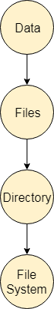

Attributes of the File
1.Name
Every file carries a name by which the file is recognized in the file system. One directory cannot have two files with the same name.
2.Identifier
Along with the name, Each File has its own extension which identifies the type of the file. For example, a text file has the extension .txt, A video file can have the extension .mp4.
3.Type
In a File System, the Files are classified in different types such as video files, audio files, text files, executable files, etc.
4.Location
In the File System, there are several locations on which, the files can be stored. Each file carries its location as its attribute.
5.Size
The Size of the File is one of its most important attribute. By size of the file, we mean the number of bytes acquired by the file in the memory.
6.Protection
The Admin of the computer may want the different protections for the different files. Therefore each file carries its own set of permissions to the different group of Users.
7.Time and Date
Every file carries a time stamp which contains the time and date on which the file is last modified.

Operations on the File
A file is a collection of logically related data that is recorded on the secondary storage in the form of sequence of operations. The content of the files are defined by its creator who is creating the file. The various operations which can be implemented on a file such as read, write, open and close etc. are called file operations. These operations are performed by the user by using the commands provided by the operating system. Some common operations are as follows:
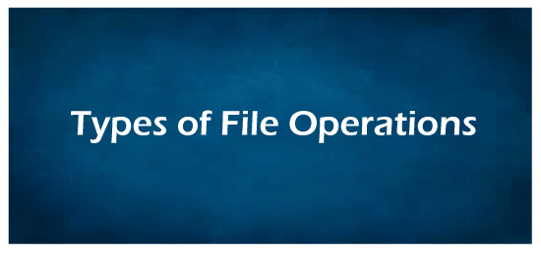
1.Create operation:
This operation is used to create a file in the file system. It is the most widely used operation performed on the file system. To create a new file of a particular type the associated application program calls the file system. This file system allocates space to the file. As the file system knows the format of directory structure, so entry of this new file is made into the appropriate directory.
2. Open operation:
This operation is the common operation performed on the file. Once the file is created, it must be opened before performing the file processing operations. When the user wants to open a file, it provides a file name to open the particular file in the file system. It tells the operating system to invoke the open system call and passes the file name to the file system.
3. Write operation:
This operation is used to write the information into a file. A system call write is issued that specifies the name of the file and the length of the data has to be written to the file. Whenever the file length is increased by specified value and the file pointer is repositioned after the last byte written.
4. Read operation:
This operation reads the contents from a file. A Read pointer is maintained by the OS, pointing to the position up to which the data has been read.
5. Re-position or Seek operation:
The seek system call re-positions the file pointers from the current position to a specific place in the file i.e. forward or backward depending upon the user's requirement. This operation is generally performed with those file management systems that support direct access files.
6. Delete operation:
Deleting the file will not only delete all the data stored inside the file it is also used so that disk space occupied by it is freed. In order to delete the specified file the directory is searched. When the directory entry is located, all the associated file space and the directory entry is released.
7. Truncate operation:
Truncating is simply deleting the file except deleting attributes. The file is not completely deleted although the information stored inside the file gets replaced.
8. Close operation:
When the processing of the file is complete, it should be closed so that all the changes made permanent and all the resources occupied should be released. On closing it deallocates all the internal descriptors that were created when the file was opened.
9. Append operation:
This operation adds data to the end of the file.
10. Rename operation:
This operation is used to rename the existing file.

File Access Methods
Let's look at various ways to access files stored in secondary memory.

Sequential Access
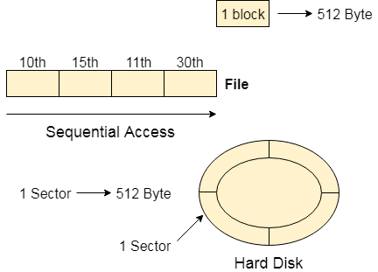
Most of the operating systems access the file sequentially. In other words, we can say that most of the files need to be accessed sequentially by the operating system.
In sequential access, the OS read the file word by word. A pointer is maintained which initially points to the base address of the file. If the user wants to read first word of the file then the pointer provides that word to the user and increases its value by 1 word. This process continues till the end of the file.
Modern word systems do provide the concept of direct access and indexed access but the most used method is sequential access due to the fact that most of the files such as text files, audio files, video files, etc need to be sequentially accessed.

Direct Access
The Direct Access is mostly required in the case of database systems. In most of the cases, we need filtered information from the database. The sequential access can be very slow and inefficient in such cases.
Suppose every block of the storage stores 4 records and we know that the record we needed is stored in 10th block. In that case, the sequential access will not be implemented because it will traverse all the blocks in order to access the needed record.
Direct access will give the required result despite of the fact that the operating system has to perform some complex tasks such as determining the desired block number. However, that is generally implemented in database applications.
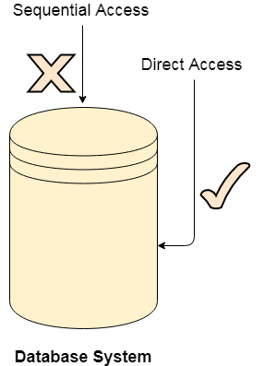

Indexed Access
If a file can be sorted on any of the filed then an index can be assigned to a group of certain records. However, A particular record can be accessed by its index. The index is nothing but the address of a record in the file.
In index accessing, searching in a large database became very quick and easy but we need to have some extra space in the memory to store the index value.

File Systems
File system is the part of the operating system which is responsible for file management. It provides a mechanism to store the data and access to the file contents including data and programs. Some Operating systems treats everything as a file for example Ubuntu.
The File system takes care of the following issues
- File Structure
We have seen various data structures in which the file can be stored. The task of the file system is to maintain an optimal file structure.
- Recovering Free space
Whenever a file gets deleted from the hard disk, there is a free space created in the disk. There can be many such spaces which need to be recovered in order to reallocate them to other files.
- disk space assignment to the files
The major concern about the file is deciding where to store the files on the hard disk. There are various disks scheduling algorithm which will be covered later in this tutorial.
- tracking data location
A File may or may not be stored within only one block. It can be stored in the non contiguous blocks on the disk. We need to keep track of all the blocks on which the part of the files reside.

File System Structure
File System provide efficient access to the disk by allowing data to be stored, located and retrieved in a convenient way. A file System must be able to store the file, locate the file and retrieve the file.
Most of the Operating Systems use layering approach for every task including file systems. Every layer of the file system is responsible for some activities.
The image shown below, elaborates how the file system is divided in different layers, and also the functionality of each layer.
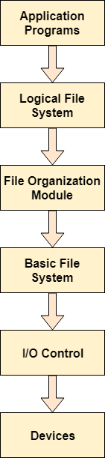
- When an application program asks for a file, the first request is directed to the logical file system. The logical file system contains the Meta data of the file and directory structure. If the application program doesn't have the required permissions of the file then this layer will throw an error. Logical file systems also verify the path to the file.
- Generally, files are divided into various logical blocks. Files are to be stored in the hard disk and to be retrieved from the hard disk. Hard disk is divided into various tracks and sectors. Therefore, in order to store and retrieve the files, the logical blocks need to be mapped to physical blocks. This mapping is done by File organization module. It is also responsible for free space management.
- Once File organization module decided which physical block the application program needs, it passes this information to basic file system. The basic file system is responsible for issuing the commands to I/O control in order to fetch those blocks.
- I/O controls contain the codes by using which it can access hard disk. These codes are known as device drivers. I/O controls are also responsible for handling interrupts.

File Access Methods
- Let's look at various ways to access files stored in secondary memory.

- Sequential Access
- 
- Most of the operating systems access the file sequentially. In other words, we can say that most of the files need to be accessed sequentially by the operating system.
- In sequential access, the OS read the file word by word. A pointer is maintained which initially points to the base address of the file. If the user wants to read first word of the file then the pointer provides that word to the user and increases its value by 1 word. This process continues till the end of the file.
- Modern word systems do provide the concept of direct access and indexed access but the most used method is sequential access due to the fact that most of the files such as text files, audio files, video files, etc need to be sequentially accessed.
- Direct Access
- The Direct Access is mostly required in the case of database systems. In most of the cases, we need filtered information from the database. The sequential access can be very slow and inefficient in such cases.
- Suppose every block of the storage stores 4 records and we know that the record we needed is stored in 10th block. In that case, the sequential access will not be implemented because it will traverse all the blocks in order to access the needed record.
- Direct access will give the required result despite of the fact that the operating system has to perform some complex tasks such as determining the desired block number. However, that is generally implemented in database applications.
- 
- Indexed Access
- If a file can be sorted on any of the filed then an index can be assigned to a group of certain records. However, A particular record can be accessed by its index. The index is nothing but the address of a record in the file.
- In index accessing, searching in a large database became very quick and easy but we need to have some extra space in the memory to store the index value.

Free Space Management
A file system is responsible to allocate the free blocks to the file therefore it has to keep track of all the free blocks present in the disk. There are mainly two approaches by using which, the free blocks in the disk are managed.

1. Bit Vector
In this approach, the free space list is implemented as a bit map vector. It contains the number of bits where each bit represents each block.
If the block is empty then the bit is 1 otherwise it is 0. Initially all the blocks are empty therefore each bit in the bit map vector contains 1.
LAs the space allocation proceeds, the file system starts allocating blocks to the files and setting the respective bit to 0.

2. Linked List
It is another approach for free space management. This approach suggests linking together all the free blocks and keeping a pointer in the cache which points to the first free block.
Therefore, all the free blocks on the disks will be linked together with a pointer. Whenever a block gets allocated, its previous free block will be linked to its next free block.

Free Space Management in OS
Challenge Inside! : Find out where you stand! Try quiz, solve problems & win rewards!

Go to Challenge

Overview
As we know, there is limited space (hard disk) in our system. So, there should be proper utilization of space or memory available in our system.
The Operating system works to allocate free space to the files when a file is created. It also creates a free void space when a file is deleted from the system. For doing all these tasks and managing spaces in our system, the operating system works with the help of a free space management system and allocates and de-allocates memory spaces simultaneously. In this article, we are going to learn about these concepts.

What is Free Space Management in OS?
There is a system software in an operating system that manipulates and keeps a track of free spaces to allocate and de-allocate memory blocks to files, this system is called a file management system in an operating system". There is a free space list in an operating system that maintains the record of free blocks.
When a file is created, the operating system searches the free space list for the required space allocated to save a file. While deletion a file, the file system frees the given space and adds this to the free space list.

Explore and unlock therecipe to transform your career
3700+
Placed at Google Amazon and other top tech companies
93.5% Placement Rate
21.6LPA Average salary of learners
126% average salary hike
₹900CR Salary created for Scaler graduates in last 4 years
Discover & connect with Alumni who have walked the same path as you

Krishna Chaitanya
Software Engineer III
Pre-Scaler
Sigmoid
Post-Scaler

200% Hike
I am a tech enthusiast now, but that was not always the case. I come from a non-tech background and used to be very unfamilia... Read Full Review

Sudhanshu Gera
Software Engineer III
Pre-Scaler
Wipro Limited
Post-Scaler

150% Hike
At the beginning, it was not the easiest of tasks to cope up with the classes but I was stern in my intent which helped me la... Read Full Review

Ankit Pangasa
Senior Software Engineer
Pre-Scaler
Adobe
Post-Scaler

200% Hike
Their course structure is impeccable and has truly helped me widen the horizons of my knowledge. They have truly established ... Read Full Review

Vikas Tiwari
Backend Developer
Pre-Scaler
Innefu
Post-Scaler

180% Hike
All thanks to Scaler Academy for providing such amazing learning resources which helped me to become a better engineer.... Read Full Review

Abinay Bingumalla
Full Stack
Pre-Scaler
Reliance Infocomm Limited
Post-Scaler

112% Hike
With Scaler, I became a lot more disciplined and focused. Without their support, maybe it would have taken me a few more year... Read Full Review

Saliq Saifi
Senior Software Engineer
Pre-Scaler
Mahindra Comviva
Post-Scaler

400% Hike
The best career decision I ever made was to join Scaler by InterviewBit. I was preparing myself but couldn't get any good opp... Read Full Review
Talk to Counsellor
Read All Reviews

Methods of Free Space Management in OS :
It is not easy work for an operating system to allocate and de-allocate memory blocks (managing free space) simultaneously. The operating system uses various methods for adding free space and freeing up space after deleting a file. There are various methods using which a free space list can be implemented. We are going to explain them below-

Bitmap or Bit Vector :
A bit vector is a most frequently used method to implement the free space list. A bit vector is also known as a Bit map. It is a series or collection of bits in which each bit represents a disk block. The values taken by the bits are either 1 or 0. If the block bit is 1, it means the block is empty and if the block bit is 0, it means the block is not free. It is allocated to some files. Since all the blocks are empty initially so, each bit in the bit vector represents 0.
Let us take an example:
Given below is a diagrammatic representation of a disk in which there are 16 blocks. There are some free and some occupied blocks present. The upper part is showing block number. Free blocks are represented by 1 and occupied blocks are represented by 0.

"Free block number" can be defined as that block which does not contain any value, �.�.i.e., they are free blocks. The formula to find a free block number is :
[Block number = (number of bits per words)*(number of 0-value word) + Offset of first 1 bit ]
We will consider the first 8 bits group (00111100011110) to constitute a non-zero word since all bits are not 0 here. Non-zero word is that word that contains the bit value 1 (block that is not free). Here, the first non-zero word is the third block of the group. So, the offset will be 3.
Hence, the block number =8∗0+3=3=8∗0+3=3
Advantages of Bit vector method:
- Simple and easy to understand.
- Consumes less memory.
- It is efficient to find free space.
Disadvantages of the Bit vector method:
- The operating system goes through all the blocks until it finds a free block. (block whose bit is '0').
- It is not efficient when the disk size is large.
Explore free courses by our top instructorsView All

TARUN LUTHRA
Java Course - Mastering the Fundamentals
73k+ enrolled

RAHUL JANGHU
Python Course for Beginners With Certification: Mastering the Essentials
62k+ enrolled

PRATEEK NARANG
C++ Course: Learn the Essentials
38k+ enrolled
35,262+ learners have attended these Courses.

Linked List :
A linked list is another approach for free space management in an operating system. In it, all the free blocks inside a disk are linked together in a linked list. These free blocks on the disk are linked together by a pointer. These pointers of the free block contain the address of the next free block and the last pointer of the list points to null which indicates the end of the linked list. This technique is not enough to traverse the list because we have to read each disk block one by one which requires I/O time.

In the above example, we have three blocks of free memory, each represented by a node in the linked list. The first block has 20 bytes of free memory, the second block has 20 bytes of free memory, and the third block has 60 bytes of free memory. The operating system can use this linked list to allocate memory blocks to processes as needed.
Advantage of the Linked list:
- In this method, available space is used efficiently.
- As there is no size limit on a linked list, a new free space can be added easily.
Disadvantages:
- In this method, the overhead of maintaining the pointer appears.
- The Linked list is not efficient when we need to reach every block of memory.

Grouping :
The grouping technique is also called the "modification of a linked list technique". In this method, first, the free block of memory contains the addresses of the n-free blocks. And the last free block of these n free blocks contains the addresses of the next n free block of memory and this keeps going on. This technique separates the empty and occupied blocks of space of memory.

Example:
Suppose we have a disk with some free blocks and some occupied blocks. The free block numbers are 3,4,5,6,9,10,11,12,13,3,4,5,6,9,10,11,12,13,, and 1414. And occupied block numbers are 1,2,7,8,15,1,2,7,8,15, and 1616 �.�.i.e., they are allocated to some files.

When the "grouping technique" is applied, block 3 will store the addresses of blocks 4, 5, and 6 because block 3 is the first free block. In the same way, block 6 will store the addresses of blocks 9, one 0, and one 1 because block 6 is the first occupied block.
Advantage of the Grouping method:
- By using this method, we can easily find addresses of a large number of free blocks easily and quickly.
Disadvantage:
- We need to change the entire list if one block gets occupied.

Counting :
In memory space, several files are created and deleted at the same time. For which memory blocks are allocated and de-allocated for the files. Creation of files occupy free blocks and deletion of file frees blocks. When there is an entry in the free space, it consists of two parameters- "address of first free disk block (a pointer)" and "a number 'n'".
Example:
Let us take an example where a disk has 16 blocks in which some blocks are empty and some blocks are occupied as given below :

When the "counting technique" is applied, the block number 3 will represent block number 4 because block 3 is the first free block. Then, the block stores the number of free blocks �.�.i.e. - there are 4 free blocks together. In the same way, the first occupied block number 9 will represent block number 10 and keeps the number of rest occupied blocks i.e.- there are 6 occupied blocks as shown in the above figure.
Advantages:
- In this method, a bunch of free blocks takes place fastly.
- The list is smaller in size.
Disadvantage:
- In the counting method, the first free block stores the rest free blocks, so it requires more space.

Conclusion
- File management system in an operating system is used to keep track of free spaces to allocate and de-allocate memory blocks to files.
- These space blocks are manipulated when there is a creation or deletion of a file in our system.
- There are various approaches for free space management in os:
  - Bit vector
  - Linked List
  - Grouping
  - Counting
- All these methods can be used for manipulating files in memory spaces.

Directory Structure in OS (Operating System)

What is a directory?
Directory can be defined as the listing of the related files on the disk. The directory may store some or the entire file attributes.
To get the benefit of different file systems on the different operating systems, A hard disk can be divided into the number of partitions of different sizes. The partitions are also called volumes or mini disks.
Each partition must have at least one directory in which, all the files of the partition can be listed. A directory entry is maintained for each file in the directory which stores all the information related to that file.
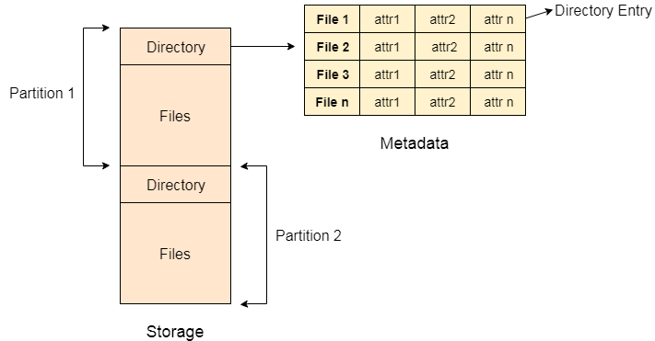
A directory can be viewed as a file which contains the Meta data of the bunch of files.
Every Directory supports a number of common operations on the file:
- File Creation
- Search for the file
- File deletion
- Renaming the file
- Traversing Files
- Listing of files

Single Level Directory
The simplest method is to have one big list of all the files on the disk. The entire system will contain only one directory which is supposed to mention all the files present in the file system. The directory contains one entry per each file present on the file system.
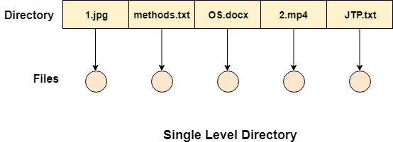
This type of directories can be used for a simple system.

Advantages
- Implementation is very simple.
- If the sizes of the files are very small then the searching becomes faster.
- File creation, searching, deletion is very simple since we have only one directory.

Disadvantages
- We cannot have two files with the same name.
- The directory may be very big therefore searching for a file may take so much time.
- Protection cannot be implemented for multiple users.
- There are no ways to group same kind of files.
- Choosing the unique name for every file is a bit complex and limits the number of files in the system because most of the Operating System limits the number of characters used to construct the file name.

Two Level Directory
In two level directory systems, we can create a separate directory for each user. There is one master directory which contains separate directories dedicated to each user. For each user, there is a different directory present at the second level, containing group of user's file. The system doesn't let a user to enter in the other user's directory without permission.
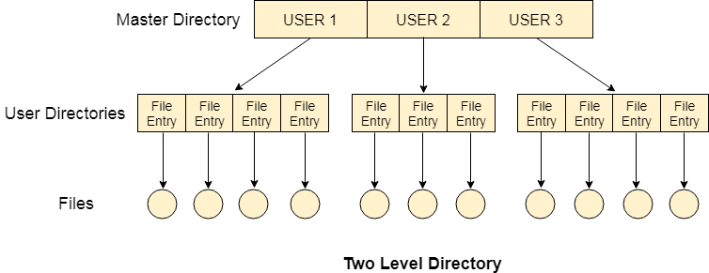

Characteristics of two level directory system
- Each files has a path name as /User-name/directory-name/
- Different users can have the same file name.
- Searching becomes more efficient as only one user's list needs to be traversed.
- The same kind of files cannot be grouped into a single directory for a particular user.
Every Operating System maintains a variable as PWD which contains the present directory name (present user name) so that the searching can be done appropriately.

Tree Structured Directory
In Tree structured directory system, any directory entry can either be a file or sub directory. Tree structured directory system overcomes the drawbacks of two level directory system. The similar kind of files can now be grouped in one directory.
Each user has its own directory and it cannot enter in the other user's directory. However, the user has the permission to read the root's data but he cannot write or modify this. Only administrator of the system has the complete access of root directory.
Searching is more efficient in this directory structure. The concept of current working directory is used. A file can be accessed by two types of path, either relative or absolute.
Absolute path is the path of the file with respect to the root directory of the system while relative path is the path with respect to the current working directory of the system. In tree structured directory systems, the user is given the privilege to create the files as well as directories.
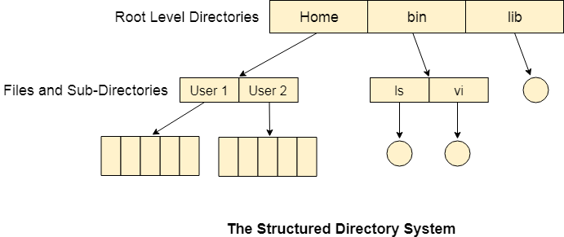

Permissions on the file and directory
A tree structured directory system may consist of various levels therefore there is a set of permissions assigned to each file and directory.
The permissions are R W X which are regarding reading, writing and the execution of the files or directory. The permissions are assigned to three types of users: owner, group and others.
There is a identification bit which differentiate between directory and file. For a directory, it is d and for a file, it is dot (.)
The following snapshot shows the permissions assigned to a file in a Linux based system. Initial bit d represents that it is a directory.

Disk Management in Operating System
The operating system is responsible for various operations of disk management. Modern operating systems are constantly growing their range of services and add-ons, and all operating systems implement four essential operating system administration functions. These functions are as follows:
- Process Management
- Memory Management
- File and Disk Management
- I/O System Management
Most systems include secondary storage devices (magnetic disks). It is a low-cost, non-volatile storage method for data and programs. The user data and programs are stored on different storage devices known as files. The OS is responsible for allocating space to files on secondary storage devices as required.
It doesn't ensure that files are saved on physical disk drives in contiguous locations. It is highly dependent on the provided space. New files are mostly stored in various locations if the disk drive is full. On the other hand, the OS example file hides that the file is divided into several parts.
The OS requires tracking the position of the disk drive for each section of every file on the disk. It may include tracking many files and file segments on a physical disk drive in some circumstances. Furthermore, the OS must be able to identify each file and conduct read and writes operations on it according to the requirements. As a result, the OS is mainly responsible for setting the file system, assuring the security and reliability of reading and writing activities to secondary storage, and keeping access times consistent.
Disk Management of the OS includes the various aspects, such as:

1. Disk Formatting
A new magnetic disk is mainly a blank slate. It is platters of the magnetic recording material. Before a disk may hold data, it must be partitioned into sectors that may be read and written by the disk controller. It is known as physical formatting and low-level formatting.
Low-level formatting creates a unique data structure for every sector on the drive. A data structure for a sector is made up of a header, a data region, and a trailer. The disk controller uses the header and trailer to store information like an error-correcting code (ECC) and a sector number.
The OS must require recording its own data structures on the disk drive to utilize it as a storage medium for files. It accomplishes this in two phases. The initial step is to divide the disk drive into one or more cylinder groups. The OS may treat every partition as it were a separate disk. For example, one partition could contain a copy of the OS executable code, while another could contain user files. The second stage after partitioning is logical formatting. The operating store stores the initial file system data structure on the disk drive in this second stage.

2. Boot Block
When a system is turned on or restarted, it must execute an initial program. The start program of the system is called the bootstrap program. It starts the OS after initializing all components of the system. The bootstrap program works by looking for the OS kernel on disk, loading it into memory, and jumping to an initial address to start the OS execution.
The bootstrap is usually kept in read-only memory on most computer systems. It is useful since read-only memory does not require initialization and is at a fixed location where the CPU may begin executing whether powered on or reset. Furthermore, it may not be affected by a computer system virus because ROM is read-only. The issue is that updating this bootstrap code needs replacing the ROM hardware chips.
As a result, most computer systems include small bootstrap loader software in the boot ROM, whose primary function is to load a full bootstrap program from a disk drive. The entire bootstrap program can be modified easily, and the disk is rewritten with a fresh version. The bootstrap program is stored in a partition and is referred to as the boot block. A boot disk or system disk is a type of disk that contains a boot partition.

3. Bad Blocks
Disks are prone to failure due to their moving parts and tight tolerances. When a disk drive fails, it must be replaced and the contents transferred to the replacement disk using backup media. For some time, one or more sectors become faulty. Most disks also come from the company with bad blocks. These blocks are handled in various ways, depending on the use of disk and controller.
On the disk, the controller keeps a list of bad blocks. The list is initialized during the factory's low-level format and updated during the disk's life. Each bad sector may be replaced with one of the spare sectors by directing the controller. This process is referred to as sector sparing.

What is RAID (Redundant Arrays of Independent Disks)?
RAID or redundant array of independent disks is a data storage virtualization technology that combines multiple physical disk drive components into one or more logical units for data redundancy, performance improvement, or both.
It is a way of storing the same data in different places on multiple hard disks or solid-state drives to protect data in the case of a drive failure. A RAID system consists of two or more drives working in parallel. These can be hard discs, but there is a trend to use SSD technology (Solid State Drives).
RAID combines several independent and relatively small disks into single storage of a large size. The disks included in the array are called array members. The disks can combine into the array in different ways, which are known as RAID levels. Each of RAID levels has its own characteristics of:
- Fault-tolerance is the ability to survive one or several disk failures.
- Performance shows the change in the read and writes speed of the entire array compared to a single disk.
- The array's capacity is determined by the amount of user data written to the array. The array capacity depends on the RAID level and does not always match the sum of the RAID member disks' sizes. To calculate the particular RAID type's capacity and a set of member disks, you can use a free online RAID calculator.
RAID systems can use with several interfaces, including SATA, SCSI, IDE, or FC (fiber channel.) Some systems use SATA disks internally but that have a FireWire or SCSI interface for the host system.
Sometimes disks in a storage system are defined as JBOD, which stands for Just a Bunch of Disks. This means that those disks do not use a specific RAID level and acts as stand-alone disks. This is often done for drives that contain swap files or spooling data.

How RAID Works
RAID works by placing data on multiple disks and allowing input/output operations to overlap in a balanced way, improving performance. Because various disks increase the mean time between failures (MTBF), storing data redundantly also increases fault tolerance.
RAID arrays appear to the operating system as a single logical drive. RAID employs the techniques of disk mirroring or disk striping.
- Disk Mirroring will copy identical data onto more than one drive.
- Disk Striping partitions help spread data over multiple disk drives. Each drive's storage space is divided into units ranging from 512 bytes up to several megabytes. The stripes of all the disks are interleaved and addressed in order.
- Disk mirroring and disk striping can also be combined in a RAID array.
In a single-user system where significant records are stored, the stripes are typically set up to be small (512 bytes) so that a single record spans all the disks and can be accessed quickly by reading all the disks at the same time.
In a multi-user system, better performance requires a stripe wide enough to hold the typical or maximum size record, allowing overlapped disk I/O across drives.

Levels of RAID
Many different ways of distributing data have been standardized into various RAID levels. Each RAID level is offering a trade-off of data protection, system performance, and storage space. The number of levels has been broken into three categories, standard, nested, and non-standard RAID levels.
Standards RAID Levels
Below are the following most popular and standard RAID levels.
1. RAID 0 (striped disks)
RAID 0 is taking any number of disks and merging them into one large volume. It will increase speeds as you're reading and writing from multiple disks at a time. But all data on all disks is lost if any one disk fails. An individual file can then use the speed and capacity of all the drives of the array. The downside to RAID 0, though, is that it is NOT redundant. The loss of any individual disk will cause complete data loss. This RAID type is very much less reliable than having a single disk.
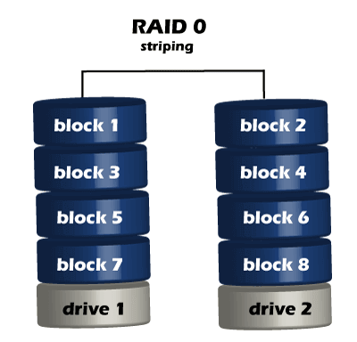
There is rarely a situation where you should use RAID 0 in a server environment. You can use it for cache or other purposes where speed is essential, and reliability or data loss does not matter at all.
2. RAID 1 (mirrored disks)
It duplicates data across two disks in the array, providing full redundancy. Both disks are store exactly the same data, at the same time, and at all times. Data is not lost as long as one disk survives. The total capacity of the array equals the capacity of the smallest disk in the array. At any given instant, the contents of both disks in the array are identical.
RAID 1 is capable of a much more complicated configuration. The point of RAID 1 is primarily for redundancy. If you completely lose a drive, you can still stay up and running off the other drive.
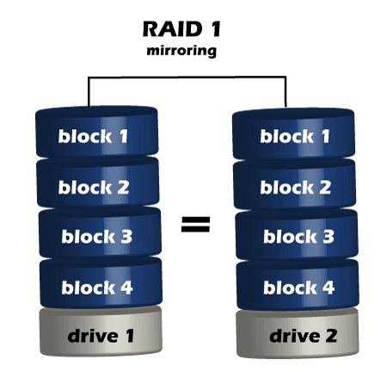
If either drive fails, you can then replace the broken drive with little to no downtime. RAID 1 also gives you the additional benefit of increased read performance, as data can read off any of the drives in the array. The downsides are that you will have slightly higher write latency. Since the data needs to be written to both drives in the array, you'll only have a single drive's available capacity while needing two drives.
3. RAID 5(striped disks with single parity)
RAID 5 requires the use of at least three drives. It combines these disks to protect data against loss of any one disk; the array's storage capacity is reduced by one disk. It strips data across multiple drives to increase performance. But, it also adds the aspect of redundancy by distributing parity information across the disks.
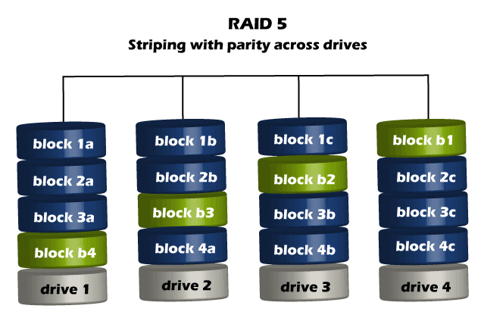
4. RAID 6 (Striped disks with double parity)
RAID 6 is similar to RAID 5, but the parity data are written to two drives. The use of additional parity enables the array to continue to function even if two disks fail simultaneously. However, this extra protection comes at a cost. RAID 6 has a slower write performance than RAID 5.
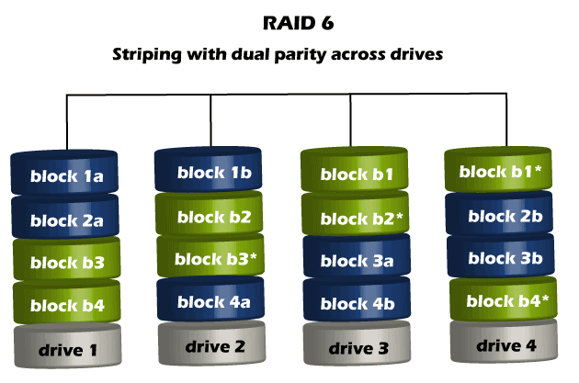
The chances that two drives break down at the same moment are minimal. However, if a drive in a RAID 5 system died and was replaced by a new drive, it takes a lot of time to rebuild the swapped drive. If another drive dies during that time, you still lose all of your data. With RAID 6, the RAID array will even survive that second failure also.
Nested RAID levels
Some RAID levels are referred to as nested RAID because they are based on a combination of RAID levels, such as:
1. RAID 10 (1+0)
This level Combines RAID 1 and RAID 0 in a single system, which offers higher performance than RAID 1, but at a much higher cost.
This is a nested or hybrid RAID configuration. It provides security by mirroring all data on secondary drives while using striping across each set of drives to speed up data transfers.
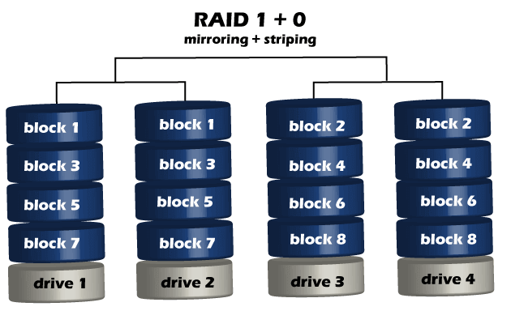
2. RAID 01 (0+1)
RAID 0+1 is similar to RAID 1+0, except the data organization method is slightly different. Rather than creating a mirror and then striping the mirror, RAID 0+1 creates a stripe set and then mirrors the stripe set.
3. RAID 03 (0+3, also known as RAID 53 or RAID 5+3)
This level uses striping similar to RAID 0 for RAID 3's virtual disk blocks. This offers higher performance than RAID 3 but at a higher cost.
4. RAID 50 (5+0)
This configuration combines RAID 5 distributed parity with RAID 0 striping to improve RAID 5 performance without reducing data protection.
Non-standard RAID levels
Non-standard RAID levels vary from standard RAID levels, and they are usually developed by companies or organizations for mainly proprietary use, such as:
1. RAID 7
A non-standard RAID level is based on RAID 3 and RAID 4 that adds caching. It includes a real-time embedded OS as a controller, caching via a high-speed bus, and other stand-alone computer characteristics.
2. Adaptive RAID
This level enables the RAID controller to decide how to store the parity on disks. It will choose between RAID 3 and RAID 5, depending on which RAID set type will perform better with the kind of data being written to the disks.
3. Linux MD RAID 10
The Linux kernel provides this level. It supports the creation of nested and non-standard RAID arrays. Linux software RAID can also support standard RAID 0, RAID 1, RAID 4, RAID 5, and RAID 6 configurations.

Implementation of RAID
The distribution of data across multiple drives can manage either by computer hardware or by software.
1. Hardware-based
Hardware-based RAID requires a dedicated controller installed in the server. Hardware RAID controllers can be configured through card BIOS or Option ROM before an operating system is booted. And after the operating system is booted, proprietary configuration utilities are available from each controller's manufacturer.
Hardware RAID is created using separate hardware. There are two options:
- AN inexpensive RAID chippossibly built into the motherboard.
- More expensive option with a complex stand-alone RAID controller. These controllers can be equipped with their CPU, battery-backed up cache memory, and typically hot-swapping.
A hardware-based RAID card does all the RAID array(s) management, providing logical disks to the system with no overhead on the part of the system itself. Additionally, hardware RAID can offer many different types of RAID configurations simultaneously to the system. This includes providing a RAID 1 array for the boot and application drive and a RAID-5 array for the large storage array.
Some other operating systems have implemented their own generic frameworks for interfacing with any RAID controller and provide tools for monitoring RAID volume status. A hardware RAID has some advantages over a software RAID, such as:
- It doesn't use the CPU of the host computer.
- It allows users to create boot partitions.
- It handles errors better since it communicates with the devices directly.
- It supports hot-swapping.
2. Software RAID
Software RAID is an included option in all of Steadfast's dedicated servers. This means there is NO cost for software RAID 1 and is highly recommended if you're using local storage on a system. It is highly recommended that drives in a RAID array be of the same type and size. Software RAID is one of the cheapest RAID solutions.
Software-based RAID will control some of the system's computing power to manage the RAID configuration. If you're looking to maximize a system's performance, such with a RAID 5 or 6 configurations, it's best to use a hardware-based RAID card when you're using standard HDDs.
Many modern operating systems provide software RAID implementations. Software RAID can be implemented as:
- A layer that abstracts multiple devices, thereby providing a single virtual machine.
- A layer that sits above any file system and provides parity protection to user data.
If a boot drive fails, the system must be sophisticated enough to boot from the remaining drive or drives.
There are certain limitations on the use of the software RAID to boot the system. Only RAID 1 can contain boot partition, while system boot is impossible with software RAID 5 and RAID 0.
In most cases, software RAID doesn't implement the hot-swapping, and so it cannot be used where continuous availability is required.

Benefits of RAID
Benefits of RAID include the following.
- An improvement in cost-effectiveness because lower-priced disks are used in large numbers.
- The use of multiple hard drives enables RAID to improve the performance of a single hard drive.
- Increased computer speed and reliability after a crash depending on the configuration.
- There is increased availability and resiliency with RAID 5. With mirroring, RAID arrays can have two drives containing the same data. It ensures one will continue to work if the other fails.

Drawbacks of RAID
RAID has the following drawbacks or disadvantages:
- Nested RAID levels are more expensive to implement than traditional RAID levels because they require many disks.
- The cost per gigabyte of storage devices is higher for nested RAID because many of the drives are used for redundancy.
- When a drive fails, the probability that another drive in the array will also soon fail rises, which would likely result in data loss. This is because all the drives in a RAID array are installed simultaneously. So all the drives are subject to the same amount of wear.
- Some RAID levels, such as RAID 1 and 5, can only sustain a single drive failure.
- RAID arrays are in a vulnerable state until a failed drive is replaced and the new disk is populated with data.
- When RAID was implemented, it takes a lot longer to rebuild failed drives because drives have much greater capacity.
However, nested RAID levels address these problems by providing a greater degree of redundancy, significantly decreasing the chances of an array-level failure due to simultaneous disk failures.
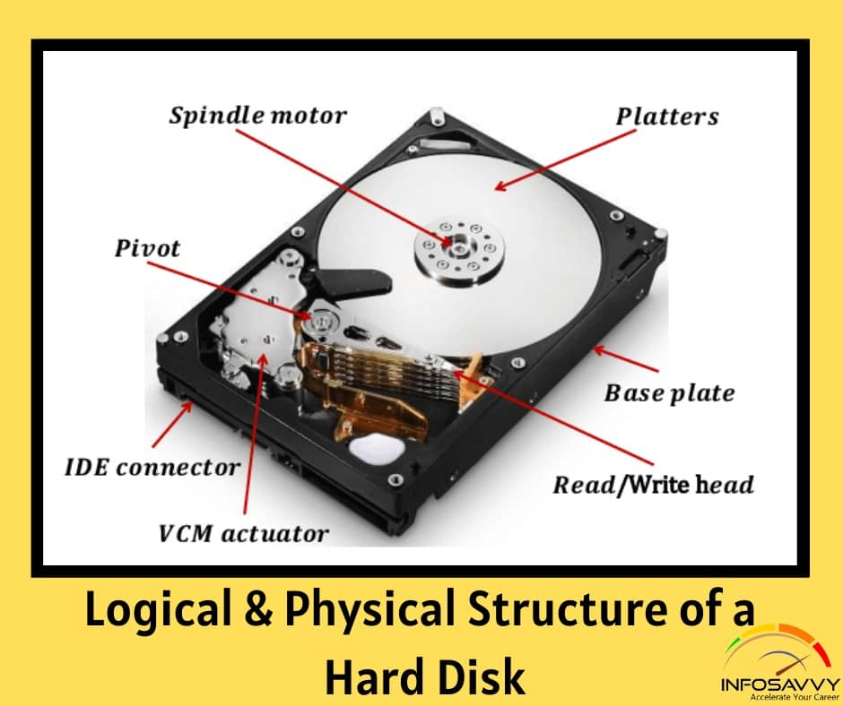

Logical & Physical Structure of a Hard Disk
Leave a Comment / CHFI, Knowledge Base / By Tushar Panhalkar
In this article explain Logical & Physical Structure of a Hard Disk there components uses.

Physical Structure of a Hard Disk
The main components of hard disk drive are:
- Platters: These are disk like structures present on the hard disk, stacked one above the other and store the data
- Head: It is a device present on the arm of the hard drive that reads or writes data on the magnetic platters, mounted on the surface of the drive
- Spindle: It is the spinning shaft on which holds the platters in a fixed position such that it is feasible for the read/write arms to get the data on the disks
- Actuator: It is a device, consisting of the read-write head that moves over the hard disk con to save or retrieve information
- Cylinder These are the circular tracks present on the platters of the disk drive at equal distances from the center
Related Product : Computer Hacking Forensic Investigator | CHFI
Physical Structure of a Hard Disk (Cont’d)
A hard disk contains a stack of platters, circular metal disks that are mounted inside the hard disk drive and coated with magnetic material, sealed in a metal case or unit. Fixed in a horizontal or vertical position, the hard disk has electromagnetic read or write heads above and below the platters. The surface of the disk consists of a number of concentric rings called as tracks; each of these tracks has smaller partitions called disk blocks. The size of each disk block is 512 bytes (0.5 KB). The track numbering starts with zero. When the platter rotates, the heads record data in tracks. A 3.5-inch hard disk can contain about thousand tracks.
The spindle holds the platters in a fixed position such that it is feasible for the read/write arms to get the data on the disks. These platters rotate at a constant speed while the drive head, positioned close to the center of the disk, reads the data slowly from the surface of the disk compared to the outer edges of the disk. To maintain integrity of data, the head is reading at a particular period of time from any drive head position. The tracks at the outer edges of the disk have less densely populated sectors compared to the tracks close to the center of the disk.
The disk fills the space based on a standard plan. One side of the first platter contains space, reserved for hardware track-positioning information which is not available to the operating system. The disk controller uses the track-positioning information to place the drive heads in the correct sector position.
The hard disk records the data using the zoned bit recording technique, also known as multiple zone recording. This method combines the areas on the hard disk together as zones, depending on the distance from the center of the disk. A zone contains a certain number of sectors per track.
Calculation of data density of disk drives is done in the following terms:
- Track density: Refers to the number of tracks in a hard disk
- Area density: Area density is the platters’ storage capacity in bits per square inch
- Bit density: It is bits per unit length of track
Also Read : Discribe the different types of Disk and there characterstics
Logical Structure of Hard Disk
A hard disk’s logical structure mainly depends on the file systems used and the software that defines the process of accessing data from the disk. Operating systems use different types of file systems, and those file systems use various other types of controlling and accessing mechanisms for data on the hard disk, Operating systems organize the same hard disk in many different ways.
The logical structure of the hard disk directly influences the consistency, performance, compatibility, and expandability of the storage subsystems of the hard disk. The logical structure depends on the type of operating system and file system used, because these factors organize and control the data access on the hard disk.
The most common computer file systems are:
- FAT
- FAT32
- NTFS
- EXT
- EXT2 and 3
- EFS

Best books for Operating System
In this article, you will learn about the best books for the operating system. But before discussing the best books for the operating system, you must know about the operating system.

What is the Operating System?
An operating system serves as a link between the user and the device's hardware. It is responsible for all functions of the system. It's also responsible for managing both software and hardware components and maintaining the system's working properly. All computer programs and apps require an operating system to do any task.
The operating system provides capabilities that aid in operating apps and are used via the proper programming. Users are the most key part of the OS. The users may control and create things by inputting data and executing various programs and services. After that comes the task of implementation, which handles the computer's overall operations and also helps in the movement of various functions such as images, movies, worksheets, and various others.
An operating system executes fundamental tasks such as recognizing keyboard input and displaying the output. It also keeps track of the disk's directories and active files. It functions as a controller and ensures that different programs and users remain signed in and don't clash on the computer system. It offers protection and safety while allowing users to access the system easily. Microsoft Windows, iOS, Linux, and Ubuntu are some examples of operating systems.

Advantages and disadvantages of the Operating System
There are various advantages and disadvantages of the Operating System. Some advantages and disadvantages of the operating system are as follows:
Advantages
- It is easy to use with a graphical user interface.
- It provides an environment in which a user may run programs and apps.
- It offers the system resources in an easy format.
- It serves as an intermediary between applications and the system hardware component.
- It allows data and relevant information to be shared with other users via Fax Machines, Printers, and Modems. Furthermore, a single user may simultaneously transfer the same data to various people via email. In addition, many software, photographs, and video files may be transferred from one system to another device using an operating system.
- It may handle multiple tasks simultaneously. It allows users to execute multiple tasks at the same time.
Disadvantages
- If an issue happens in the operating system, you may lose all of the data stored on your system.
- Operating system threats are greater because they are more vulnerable to viral attacks. Many individuals install malicious software packages on their devices, which halts and delays the operation of the operating system.
- Operating systems are highly complex, and the language used to develop them is both ambiguous and well-defined. Furthermore, if there is a problem with the operating system that users do not understand, it will take time to resolve.
- It needs improvement with using the TLB.

Top books for the operating system
There are various books for the operating system. Some books of the operating system are as follows:
- Operating System Concepts
- Operating System: A Design-oriented Approach
- Design of the Unix Operating Systems
- Operating Systems
- Operating Systems: A Concept-Based Approach
- Guide to Operating Systems
- Operating System Concepts: Windows Xp Update 6th Edition
- MODERN OPERATING SYSTEMS
- Operating Systems: A Modern Perspective
- Unix - The Complete Reference
- Operating Systems: Internals and Design Principles
- Operating System Design: The Xinu Approach
- Understanding Operating Systems
- Operating Systems: Three Easy Pieces
- Operating Systems: Principles and Practice

Operating System Concepts
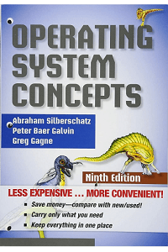
Authors: Abraham Silberschatz and Peter Galvin
This book explains all of the fundamental concepts that underlie OSs. The book includes various examples that are relevant to Oss, including UNIX, IBM, Apple, Solaris, Windows NT, and Linux. The introduction of java technology has illustrated important concepts in operating systems. The book uses the concept of java technology to demonstrate topics such as multitasking, CPU scheduling, process synchronization, deadlock, and security. There are various examples of OSs like Windows NT, Solaris, and Linux. A separate chapter on threads explains how the OS manages thread scheduling.

Operating System: A Design-oriented Approach
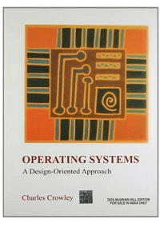
Author: Charles Crowley
This book covers all of the fundamental ideas of operating systems and demonstrates how they have evolved into their present forms. Code segments and case studies are available for various operating systems, including MacOS, MS/DOS, Windows NT, OS/2, and various UNIX versions. The author also went through design tools and important approaches for designing and implementing OS data structures. However, the overall approach is UNIX-oriented, and the book also covers how to implement the mentioned concepts in various major operating systems. A simulator is provided for instructors and students to run the code implementing the OS.

Design of the UNIX Operating Systems
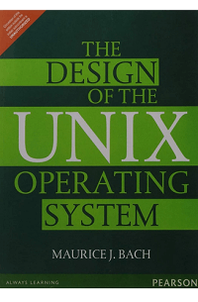
Author: Maurice Bach
This book describes the essential principles of internal algorithms and deconstructs the relationship between the operating system's kernel and the programmer interface. It may be used by programmers to code more efficiently or to compare the algorithms used in UNIX to those used in other operating systems. The author has also gone into the evolution of OS in an easy-to-understand manner. Some of the activities in the book demonstrate concepts at a deeper level, while others are investigative in nature. They differ in difficulty, with the most difficult ones denoted with an asterisk.

Operating Systems
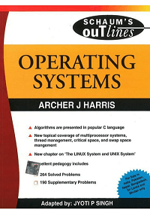
Author: Archer J Harris
This book is written for professionals and students who require reviewing key topics and improving problem-solving skills to pass graduate or exams. The book describes the important underlying principles of all major OS designs, including Linux, UNIX, and DOS. Various concepts include file systems, memory, virtual memory, device I/O, synchronization, and security. These are explained concisely, followed by solved examples after every concept. There are separate chapters for basic C, C++, FORTRAN 77 and 90, Java, Pascal, and Modern Structured COBOL programming.

Operating Systems: A Concept-Based Approach
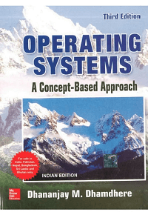
Author: D M Dhamdhere
The book contains exact definitions and concise explanations of essential operating system concepts. This book is ideal for students studying operating systems. The book includes concepts, approaches, and case studies that are well integrated with numerous design and implementation details. The book explains each operating system concept and the latest technologies such as encryption and security. The book also includes various case studies that are tied to real-world operating system experiences.

Guide to Operating Systems
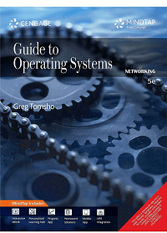
Author: Greg Tomsho
This operating system book allows you to examine operating system theory, installation, configuring operating system and hardware, file systems, updating, security, hardware alternatives, virtualization, network connectivity, maintenance, storage, resource sharing, and troubleshooting.
This book will help you to learn more about different operating systems in an easy-to-understand and practical way. This book helps you via the basic concepts of computer OS step-by-step. The book covers Fedora Linux, Windows Server 2012 R2, Windows 10 and earlier Windows client OS, and earlier Windows server OS, with a preview of Windows Server 2016, Mac OS X El Capitan, and older Mac OS. Furthermore, the author gives large information that will prepare you to work with various operating systems and will encounter them in your career or line of work.

Operating System Concepts: Windows Xp Update 6th Edition
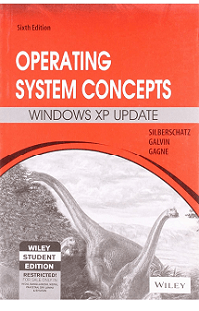
Author: Silberschatz Galvin Gagne
The book provides a theoretical introduction to the fundamental ideas of operating systems and an overview of their internal workings and functions. The book's case studies and issues help readers understand OS fundamentals better. Concepts like Windows XP, Solaris, client-server model, FreeBSD, Linux, Java threads, extended coverage of NFS, compact footprinting OSs for PDAs, and real-time operating systems have all been analyzed in great detail. The authors also discuss how Solaris, Linux, and Windows implement a given process/thread differently. This book is appropriate for both students and professionals who need a basic understanding of operating systems.

MODERN OPERATING SYSTEMS
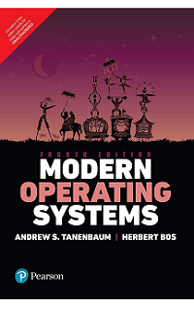
Author: Andrew S Tanenbaum and Herbert BOS
This book includes detailed case studies on UNIX, Linux, and Windows 2000 and comprehensive conceptual knowledge about OS designs. Some basic concepts, including I/O, file systems, deadlocks, processes, and memory management, are all researched and discussed. The author's discussion of the previous OS designs will benefit both students and professionals. The book also easily and easily covers the latest operating system technologies and developments. The book's lab experiments and simulation exercises will be useful for operating system professionals and students with backgrounds in Computer Science and Electrical Engineering.

Operating Systems: A Modern Perspective
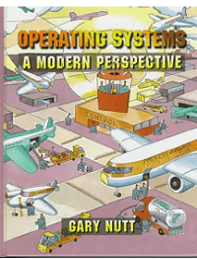
Author: Gary J Nutt
The book combines the operating systems design concepts with how they are implemented in the real world. The book includes a comprehensive overview of operating system fundamentals, as well as real-world code samples, algorithms, and numerous talks concerning implementation challenges. Furthermore, the book includes various lab tasks that students can practice with Linux and Windows. The material in the book assists students in distinguishing between the foundations of operating systems and code examples. Furthermore, stress is made on how various operating system components connect to real-world restrictions.

UNIX - The Complete Reference
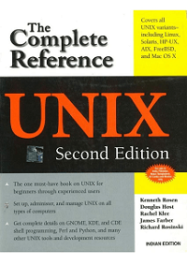
Author: Ken Rosen, James Farber, Douglas Host, Rachel Klee, and Richard Rosinski
This operating system book explains the UNIX releases such as FreeBSD, AIX, HP-UX, Solaris 10, and all Linux versions in detail. The book explains how to use UNIX and how to make the most of its tools and applications. There are also new chapters on Samba, UNIX desktops, Java Apache, Python, and UNIX web development. This book lives up to its name as the comprehensive UNIX reference book. It covers everything from writing Python, Shell, Perl scripts to managing emails, security, and setting up Apache Web servers. It may be used by both starters and professionals with prior expertise.

Operating Systems: Internals and Design Principles
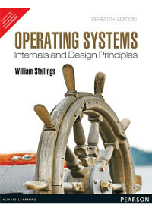
Author: William Stallings
This book gives a complete and deep introduction to operating system subjects, focusing on both design issues and fundamental ideas in modern operating systems. The book also gives users a better understanding of the basic operating system components and functions. It covers trade-offs and practical issues that affect the system's design, performance, and security. It also explains and reinforces the design topics while connecting them to the real world. It also discusses the latest OS trends and advanced developments.

Operating System Design: The Xinu Approach
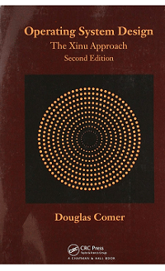
Author: Douglas Comer
This OS book is widely lauded for avoiding the usual black box approach found in other OS textbooks. This book's initial version described how operating systems function and how to build one from the ground up.
It helps to remove the mystery from OS design, consolidates the body of content into a systematic discipline, and follows a logical system design pattern. It also introduces a hierarchical design approach for organizing major OS components logically and understandably.
It helps readers via the process of building a traditional process-based OS using practical and simple primitives. It provides implementation details for a single set of primitives. Once the readers understand how primitives may be used on conventional hardware, readers may easily implement alternative versions.

Understanding Operating Systems
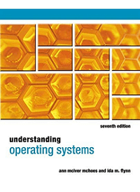
Authors: Ann McHoes and Ida M. Flynn
This book provides a clear and easy explanation of both contemporary operating system theory and the latest practices. Its proven approach starts with a valuable discussion of basic concepts before introducing a particular OS. It also analyzes how modern innovations like multi-core processing and wireless technologies have affected the latest OS. It provides fully updated and current content.
The revised research topic practical exercises in this book allow the readers to perform independent research on emerging and influential topics. Furthermore, the final four chapters have been updated to include information on the latest versions of UNIX, Linux, Windows, and Android to provide users with the most updated knowledge and abilities for working most successfully with today's systems.

Operating Systems: Three Easy Pieces
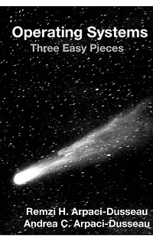
Author: Remzi Arpaci-Dusseau and Andrea Arpaci-Dusseau
This book was written in the classrooms of the University of Wisconsin-Madison and has been in the instruction of thousands of students. It was written by professors who have been working on the concept for 20 years. The fundamental concepts of operating systems covered in this book include file and storage systems, processor and memory virtualization, and threads and concurrency.
The authors of this text present clear and concise information for students and anybody interested in learning how operating systems work and how to implement the fundamentals to them.

Operating Systems: Principles and Practice
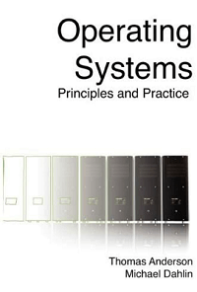
Author: Thomas Anderson and Michael Dahlin
It is a textbook for a first course in undergraduate OS. It was written by two great OS researchers with decades of experience in teaching complex concepts to thousands of students and is used at several prestigious colleges. It provides a path for students to follow from high-level concepts to practical code. It is mainly focused on updated industry technologies and practices.

Conclusion
Operating systems are the defining feature of technology. They work quietly and persistently behind the scenes, and they are the true heroes of the technological revolution. Operating Systems are present, energetic, and attentive in smartphones, computers, and servers. Learning about these giants is a better way to understand better how the deeper things work and interconnect. Choose a book or two to begin your journey into the world of operating systems

